Git Commands

1. We are creating project and there are chances of creating multiple projects Exe/D11 ( extension for .dotnot
2. Projects are managed by solution

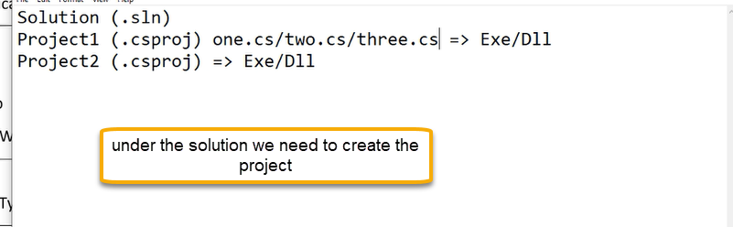

1. Create the project in local

(Microsoft Windows [Version 10.0.18363.1440]

(c) 2019 Microsoft Corporation. All rights reserved.

C:\Users\Sravan>.net version

'.net' is not recognized as an internal or external command,

operable program or batch file.

C:\Users\Sravan>dotnet --version

5.0.201

C:\Users\Sravan>dotnet new sln -o HelloWorldApp

Welcome to .NET 5.0!

---------------------

SDK Version: 5.0.201

Telemetry

---------

The .NET tools collect usage data in order to help us improve your experience. It is collected by Microsoft and shared with the community. You can opt-out of telemetry by setting the DOTNET_CLI_TELEMETRY_OPTOUT environment variable to '1' or 'true' using your favorite shell.

Read more about .NET CLI Tools telemetry: https://aka.ms/dotnet-cli-telemetry

----------------

Installed an ASP.NET Core HTTPS development certificate.

To trust the certificate run 'dotnet dev-certs https --trust' (Windows and macOS only).

Learn about HTTPS: https://aka.ms/dotnet-https

----------------

Write your first app: https://aka.ms/dotnet-hello-world

Find out what's new: https://aka.ms/dotnet-whats-new

Explore documentation: https://aka.ms/dotnet-docs

Report issues and find source on GitHub: https://github.com/dotnet/core

Use 'dotnet --help' to see available commands or visit: https://aka.ms/dotnet-cli

--------------------------------------------------------------------------------------

Getting ready...

The template "Solution File" was created successfully.

C:\Users\Sravan>cd HelloWorldApp

C:\Users\Sravan\HelloWorldApp>dotnet new mvc -n HelloWorldApp.Web

The template "ASP.NET Core Web App (Model-View-Controller)" was created successfully.

This template contains technologies from parties other than Microsoft, see https://aka.ms/aspnetcore/5.0-third-party-notices for details.

Processing post-creation actions...

Running 'dotnet restore' on HelloWorldApp.Web\HelloWorldApp.Web.csproj...

Determining projects to restore...

Restored C:\Users\Sravan\HelloWorldApp\HelloWorldApp.Web\HelloWorldApp.Web.csproj (in 185 ms).

Restore succeeded.

C:\Users\Sravan\HelloWorldApp>

C:\Users\Sravan\HelloWorldApp> dotnet sln HelloWorldApp.sln add HelloWorldApp.Web\HelloWorldApp.Web.csproj

Project `HelloWorldApp.Web\HelloWorldApp.Web.csproj` added to the solution.

C:\Users\Sravan\HelloWorldApp>cd HelloworldApp.web

C:\Users\Sravan\HelloWorldApp\HelloWorldApp.Web>dotnet run

Building...

info: Microsoft.Hosting.Lifetime[0]

Now listening on: https://localhost:5001

info: Microsoft.Hosting.Lifetime[0]

Now listening on: http://localhost:5000

info: Microsoft.Hosting.Lifetime[0]

Application started. Press Ctrl+C to shut down.

info: Microsoft.Hosting.Lifetime[0]

Hosting environment: Development

info: Microsoft.Hosting.Lifetime[0]

Content root path: C:\Users\Sravan\HelloWorldApp\HelloWorldApp.Web

info: Microsoft.Hosting.Lifetime[0]

Application is shutting down...

C:\Users\Sravan\HelloWorldApp\HelloWorldApp.Web>dir

Volume in drive C is OS

Volume Serial Number is 7CAE-D8BC

Directory of C:\Users\Sravan\HelloWorldApp\HelloWorldApp.Web

03/25/2021 06:00 PM <DIR> .

03/25/2021 06:00 PM <DIR> ..

03/25/2021 05:54 PM 162 appsettings.Development.json

03/25/2021 05:54 PM 192 appsettings.json

03/25/2021 06:00 PM <DIR> bin

03/25/2021 05:54 PM <DIR> Controllers

03/25/2021 05:54 PM 141 HelloWorldApp.Web.csproj

03/25/2021 05:54 PM <DIR> Models

03/25/2021 06:00 PM <DIR> obj

03/25/2021 05:54 PM 725 Program.cs

03/25/2021 05:54 PM <DIR> Properties

03/25/2021 05:54 PM 1,836 Startup.cs

03/25/2021 05:54 PM <DIR> Views

03/25/2021 05:54 PM <DIR> wwwroot

5 File(s) 3,056 bytes

9 Dir(s) 121,412,993,024 bytes free

C:\Users\Sravan\HelloWorldApp\HelloWorldApp.Web>)

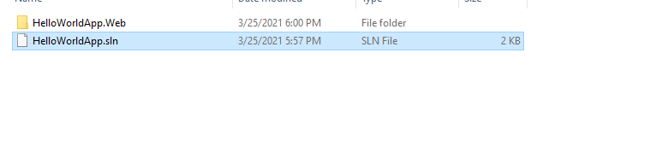

1. We need to move the local code into Azure Repo and for that in the local machine we need add to local git
2. Use the command git init

C:\Users\Sravan\HelloWorldApp\HelloWorldApp.Web>cd..

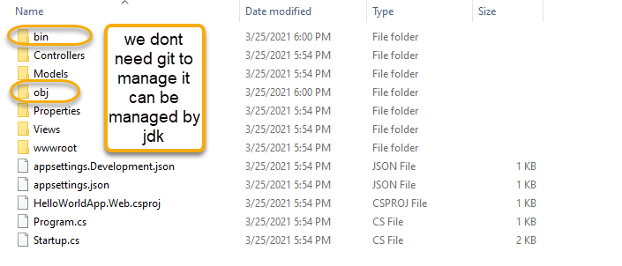

6 go to visual studio code ( code .)

1. Go to the view > extensions and install gitignore
2. Click on Fn+F1 select/Add gitignore ◊ VisualStudio.gitignore ◊ Press Enter
3. Then click on the file and file directory

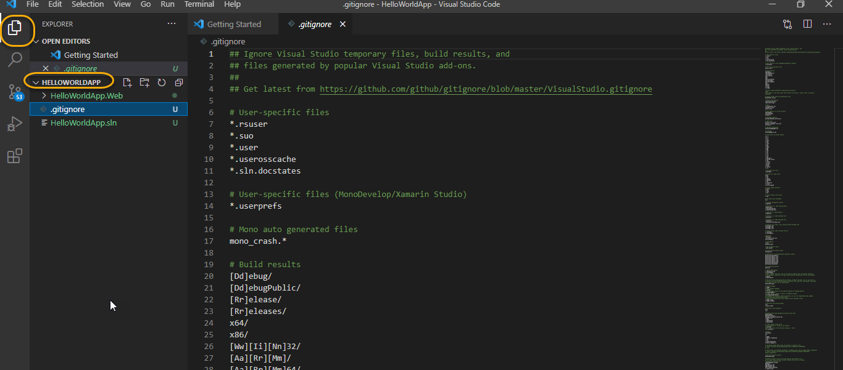

1. The files and folder (shown above) are excluded from my local repository when I am committing into local git
2. Git ignore is added

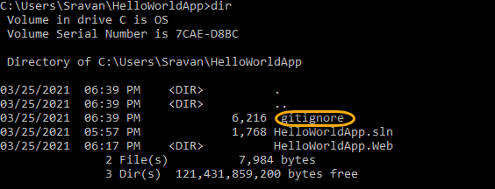

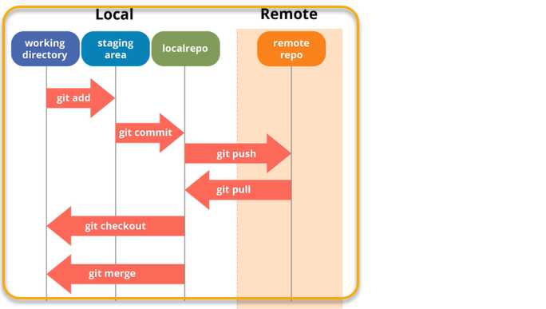

* git status

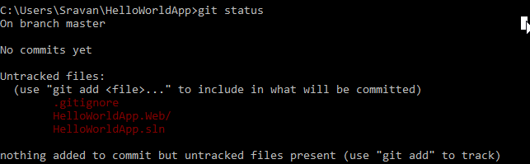

To stage the files we need to use

git add .(usually we need mention file names and if you need all files use .(dot)) and excluding git ignore ( git add(space).)

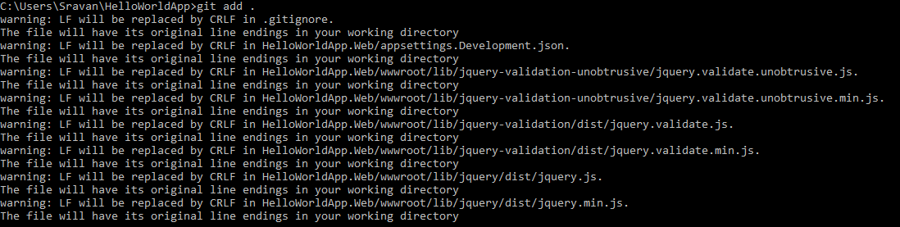

git status

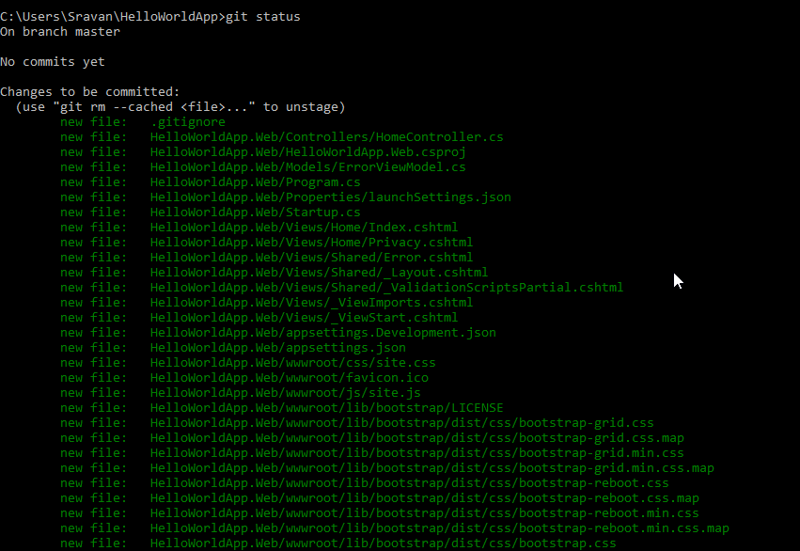

NOW it is in staged condition

When ever we commit it will create the snapshot we need to give some comment “ Initial state” (-m is message)

git commit -m "Intial State"

git status

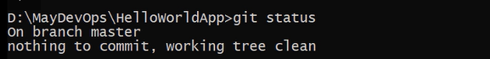

Nothing to commit because everything is committed

git log ( how many commit has been done)

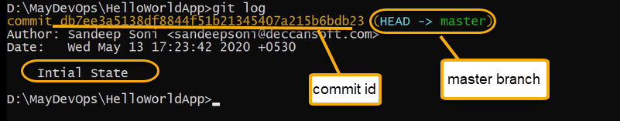

Author: name of person who commit

gitadd/gitcommit ( how internally working)

now it will go into the localrepo

enter (code . ( visual studio will open)



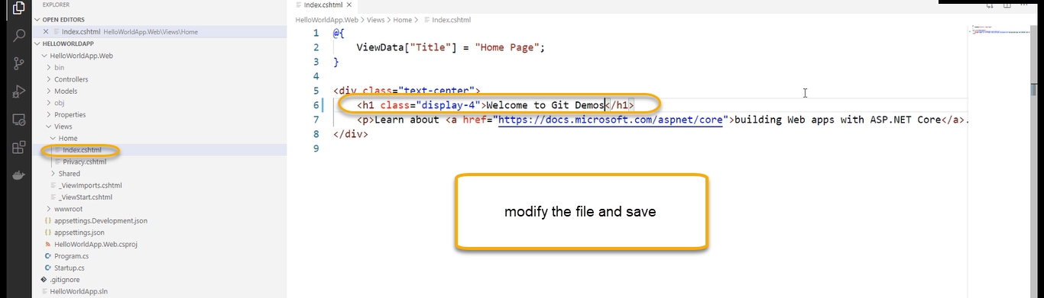

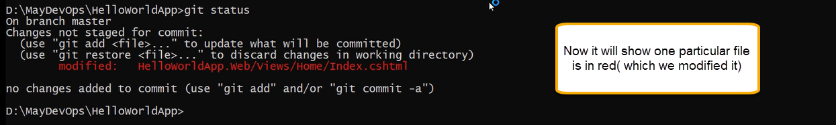

That is edited file NOT staged

Now we need to stage the modified files

For that use git add ( file name)



And again, run git status

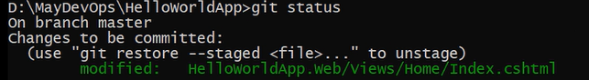

The file has been staged

And we need to commit it

git commit -m “tittle edited’’ ( will take the differential updates and committing those changes) all the files which are in staged and for every file see the difference and difference is comitted

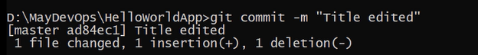

git log

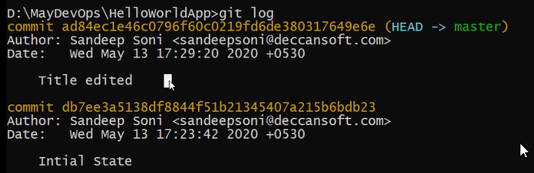

Roll back ( differentials will be deleted) differentials will keep reverting

Git branch -l (which list out of the branches present)



Code should be stable in all the times and we need to work on various features and during that we may have multiple commit points

To config the user name and email

git config user.name sandeep git config user.email [sandeep@dss.com](mailto:sandeep@dss.com)

Once you are ready to share your code, get the clone URL for the repository you want to connect to and then set

up a remote relationship (in this case, origin) so your repo can push changes to a shared repo.

8. DevOps Portal → Project → Repos → In bread crump expand arrow → select New repository.

9. In the Create a new repository dialog, verify that Git is the repo type and enter a name for your new repo

Execute the following command to connect to Git Server

git remote add origin <URL>

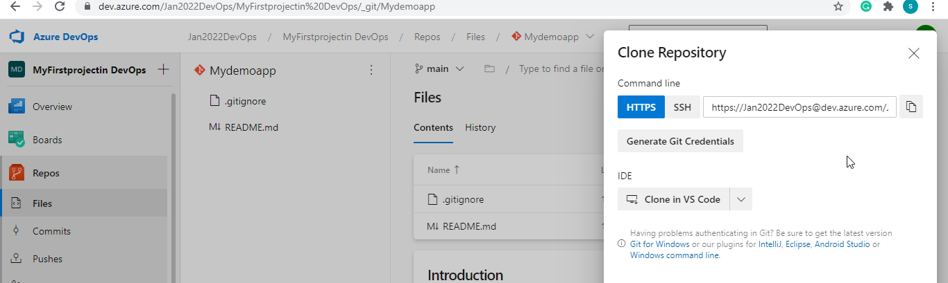

It prompts for sign in if Visual studio code is installed else Git asks for credentials to sign in. Sign in with the DevOps

credentials.

If the Origin and local copy are not in Sync - Pull the origin master to local

git pull --allow-unrelated-histories origin master

Push the changes to the Server repository.

git push origin master

If the local folder is Empty then use the following command to clone the remote repo to local. git clone <url>

Some suggestions for naming your feature branches: 1. features/feature-name 2. features/feature-area/feature-name 3. users/username/description 4. users/username/workitem 5. bugfix/description 6. hotfix/description

Merging is Git's way of putting a forked history back together again.

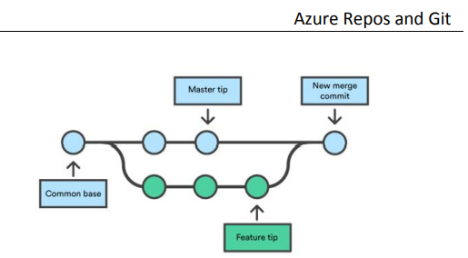

To create the merge we need to create the

git merge <branch name>

git checkout for selecting the current branch

Again, this means that git merge is often used in conjunction with git checkout for selecting the current branch

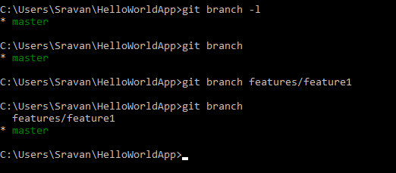

Any kind of changes which I am going to do are reflect in my main branch

I should not make changes to master branch

I need to do changes to feature branch

We need to run the below command

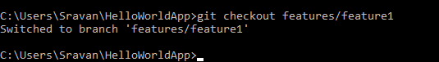

Now my features/feature1 is the feature branch

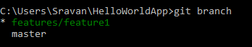

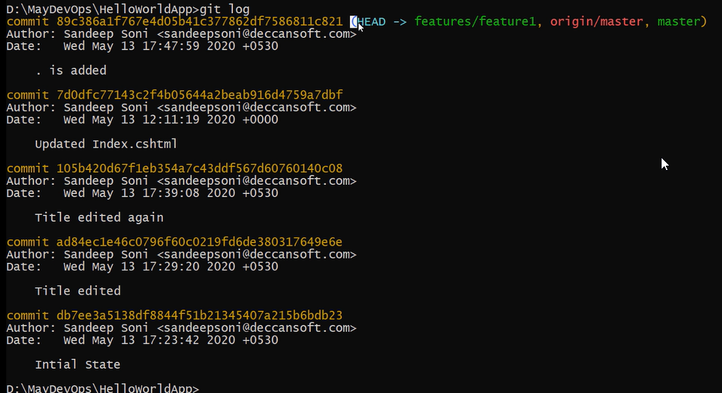

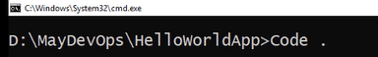

Actually, changing code in the branch

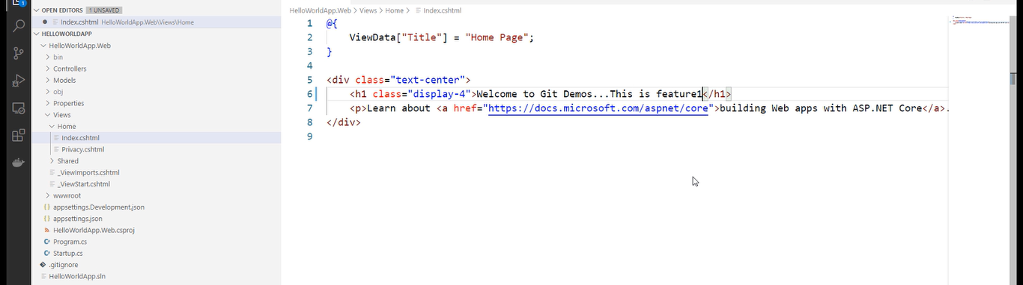

git status

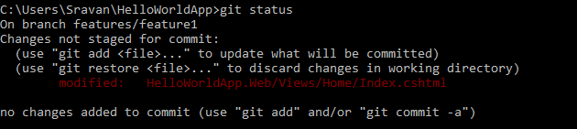

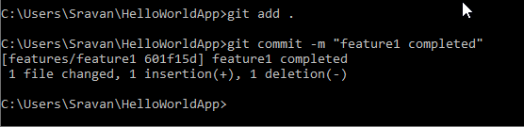

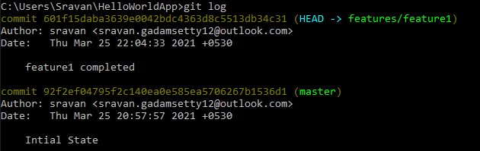

If you are merging main branch to feature branch, then we need to do git checkout master

git branch

git merge features/feature1

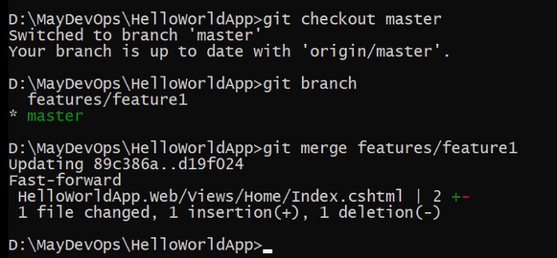

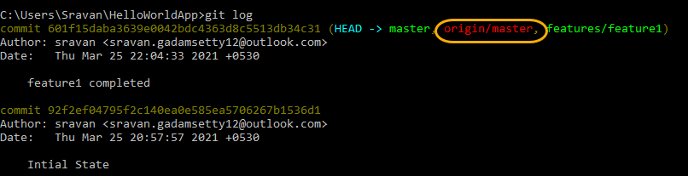

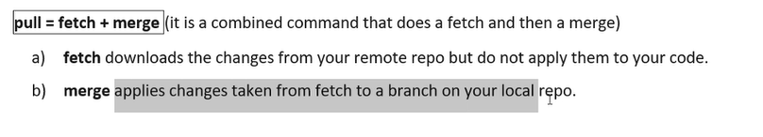

After feature branch is merged to main branch we can delete it

git branch -d features/feature1

git branch

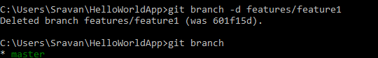

If the code changes are not stable in feature branch, we can forcefully delete it

git branch -D features/feature1

if you try it deleting using the -d instead of D then it will not delete it forcefully until feature branch is merged to main branch

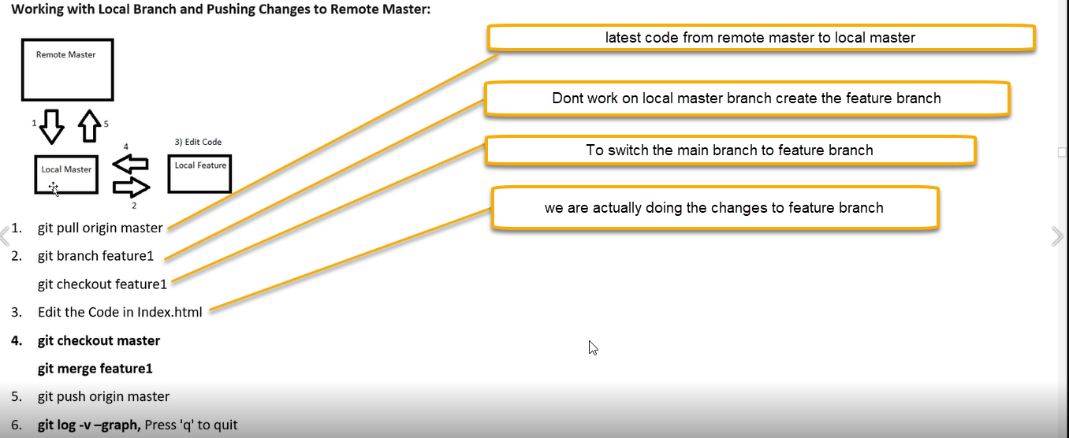

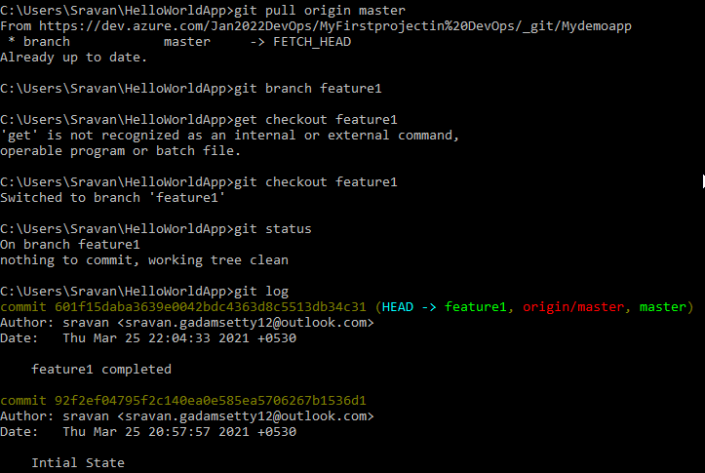

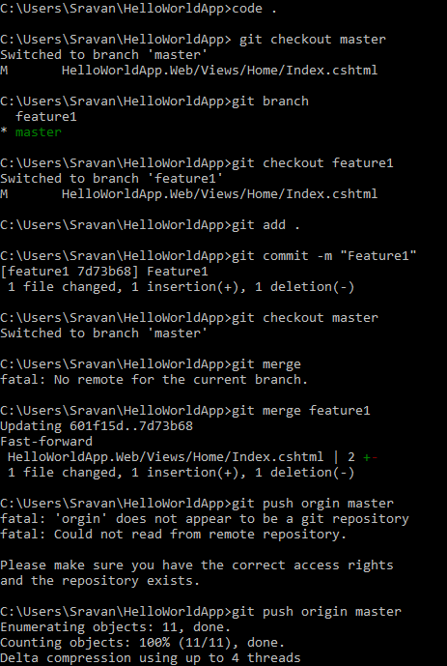

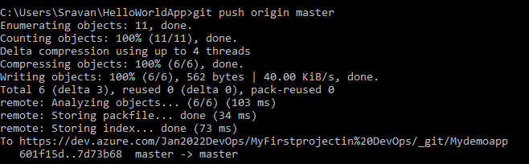

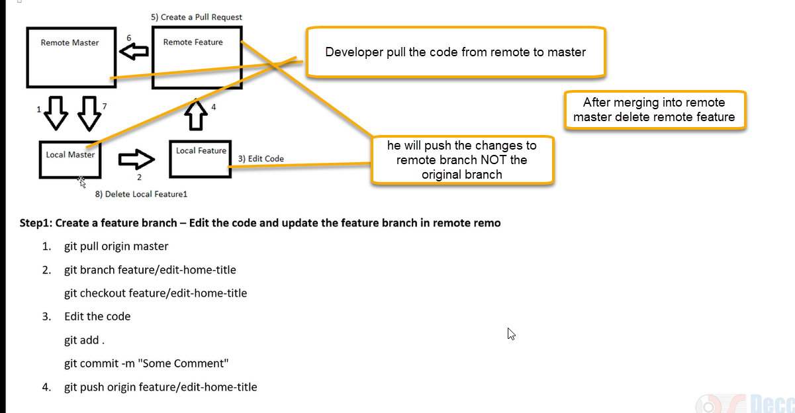

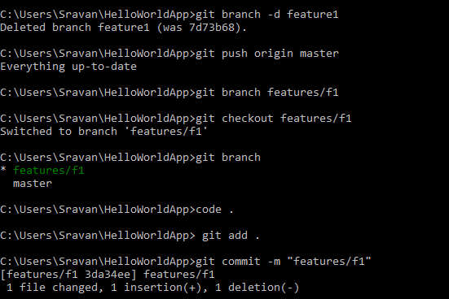

Now if you need to merge, we need approval from concerned person so we are pushing to remote feature

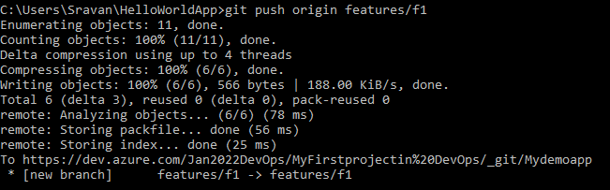

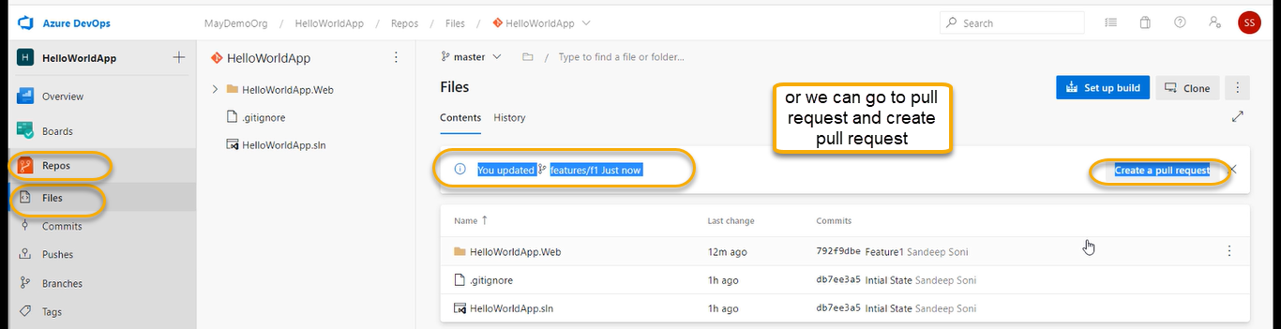

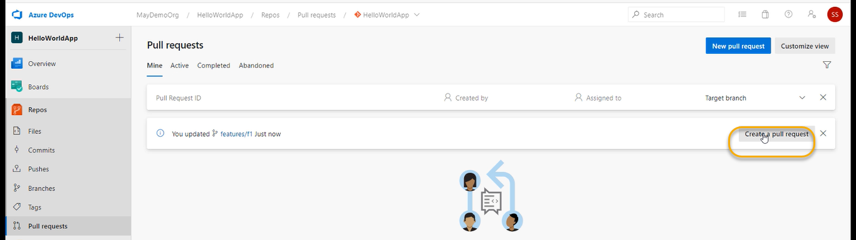

Or click on New Pull Request

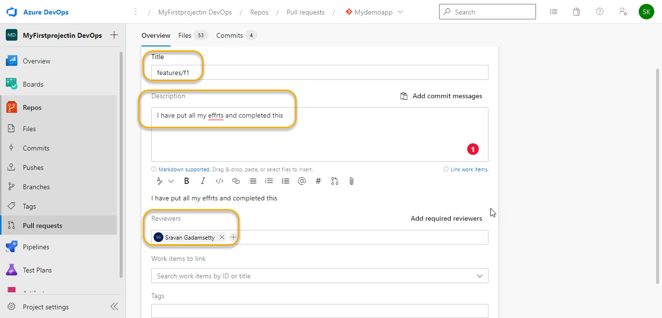

And click on Request

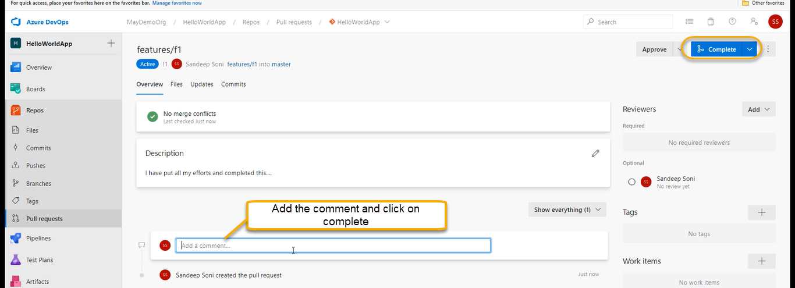

Click on Complete

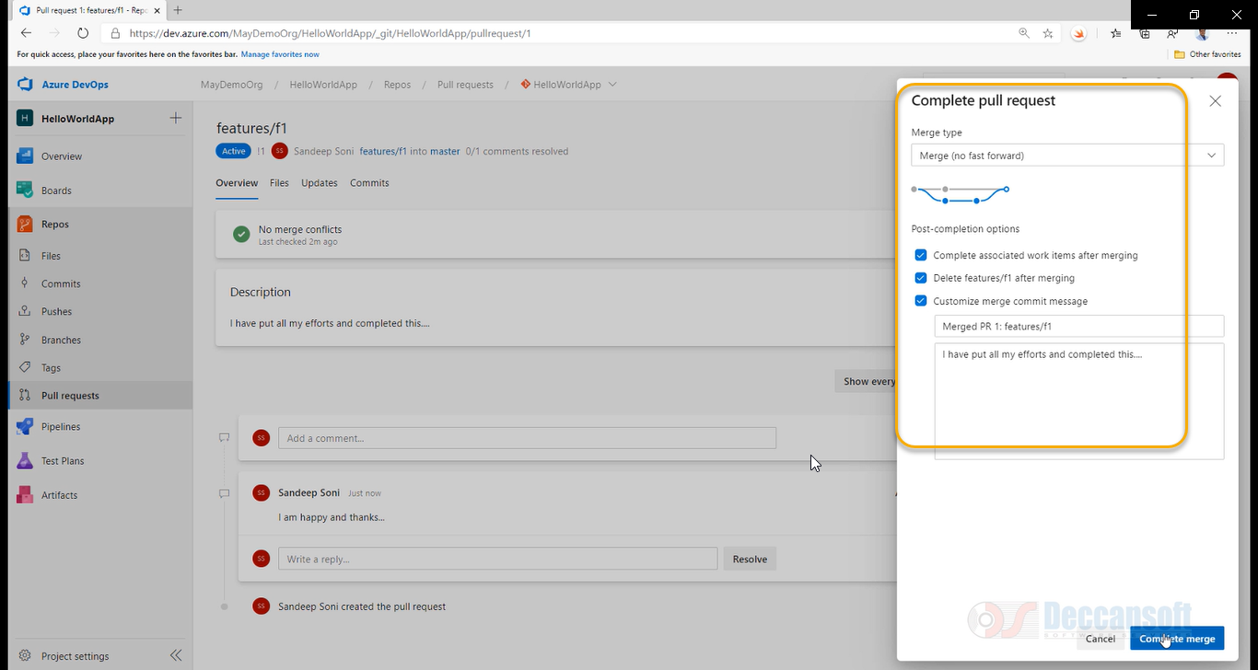

Delete the feature branch. Navigate to Branches

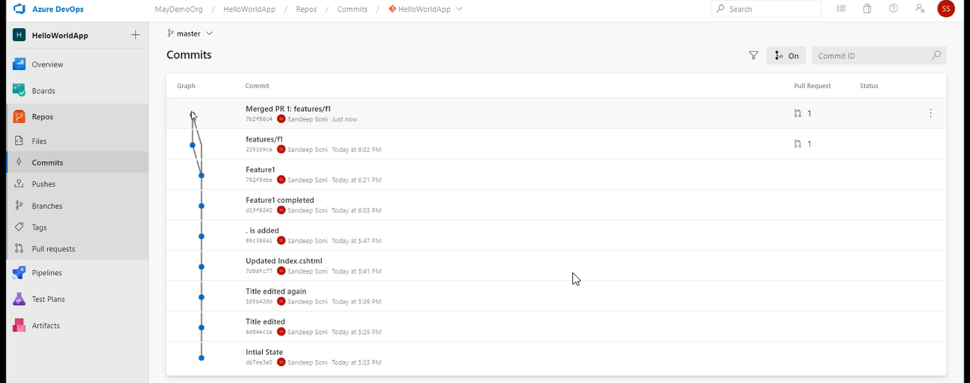

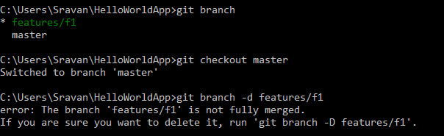

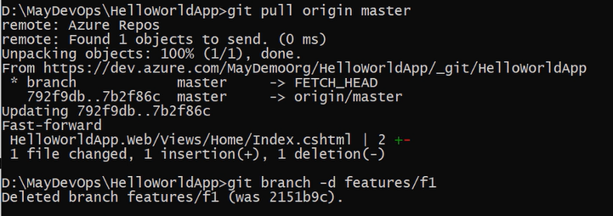

Up to now we have created and approved the pull request from ourself and that is not a good practice we need to create the policy

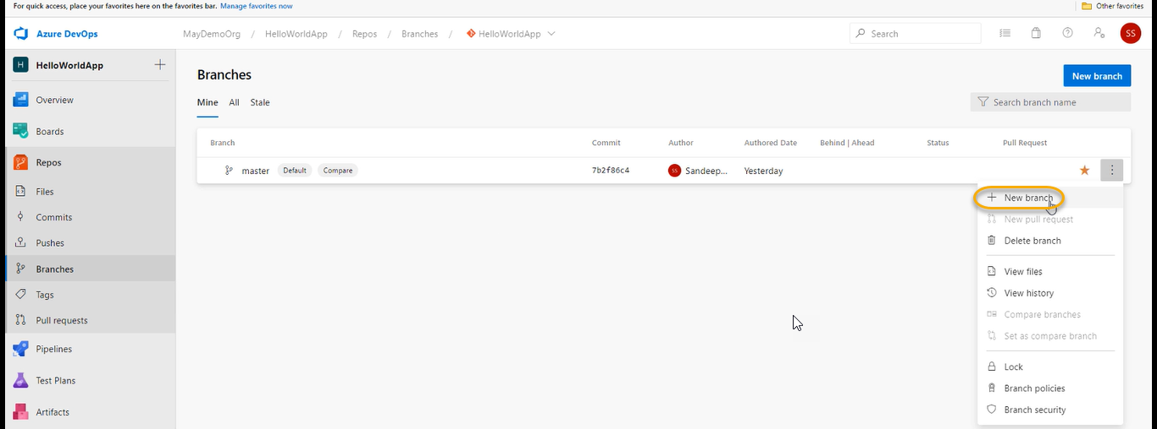

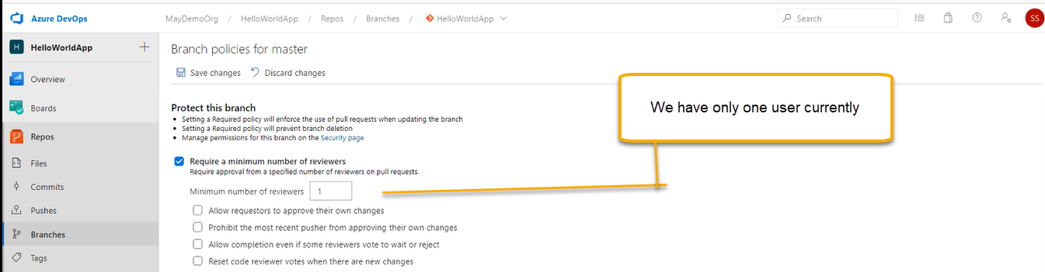

And click on save changes

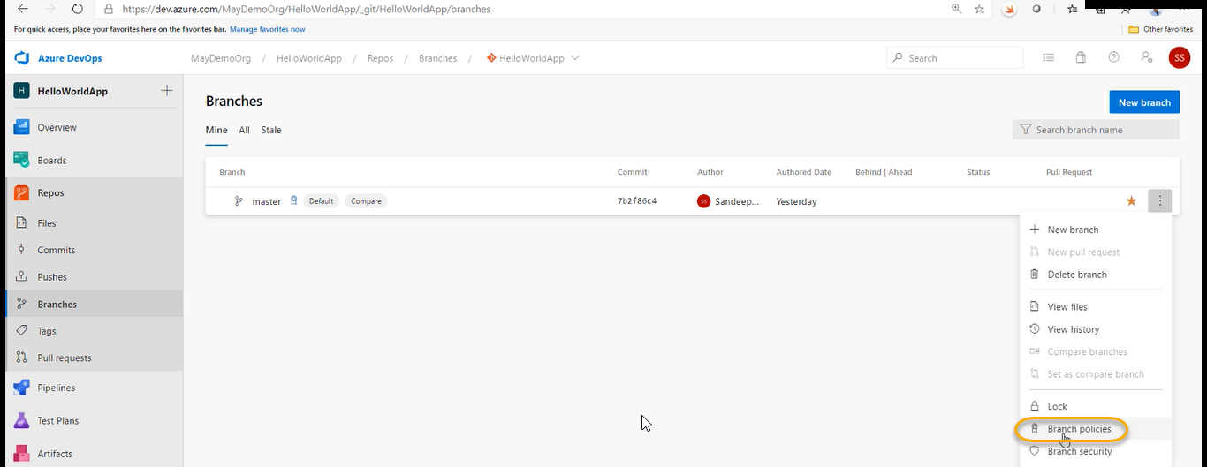

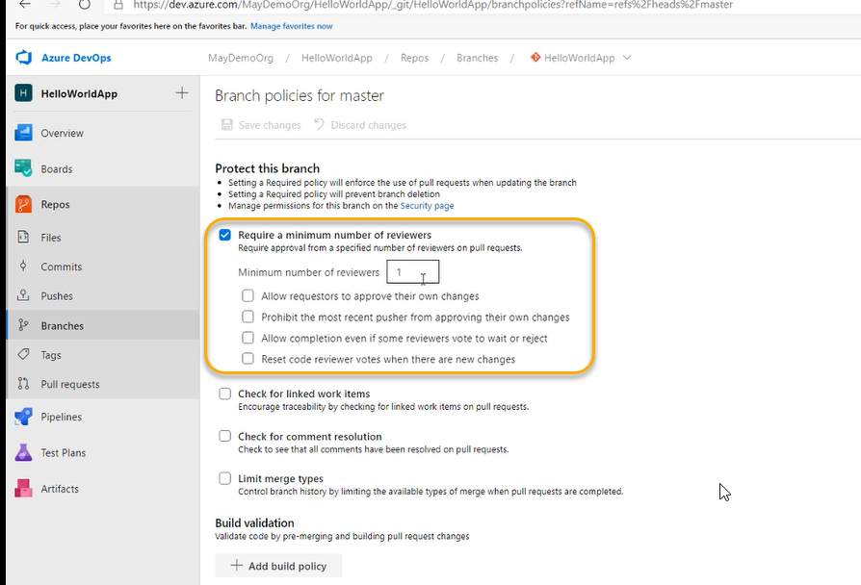

If you are getting an error while executing the pull origin master then execute the below one

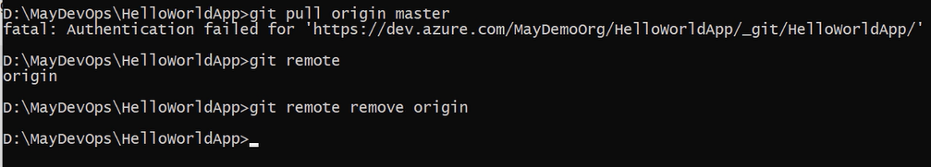

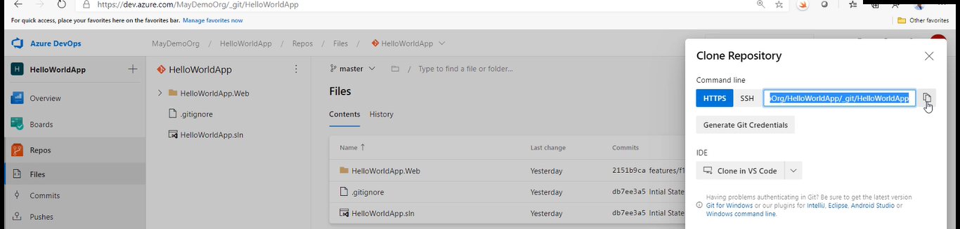



And if the issue still exist then go to the below and remove

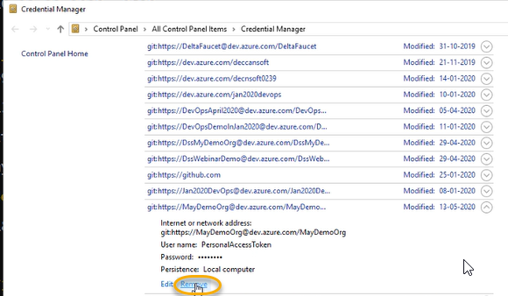



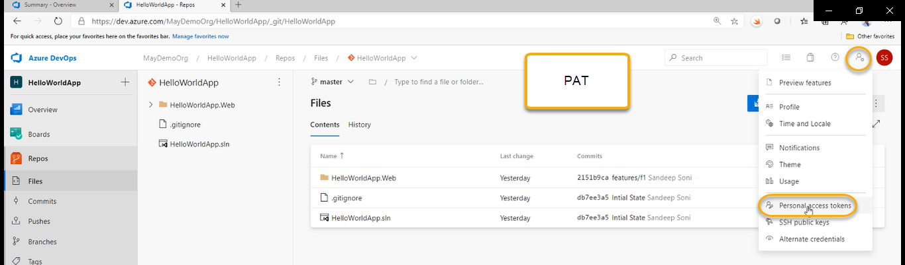

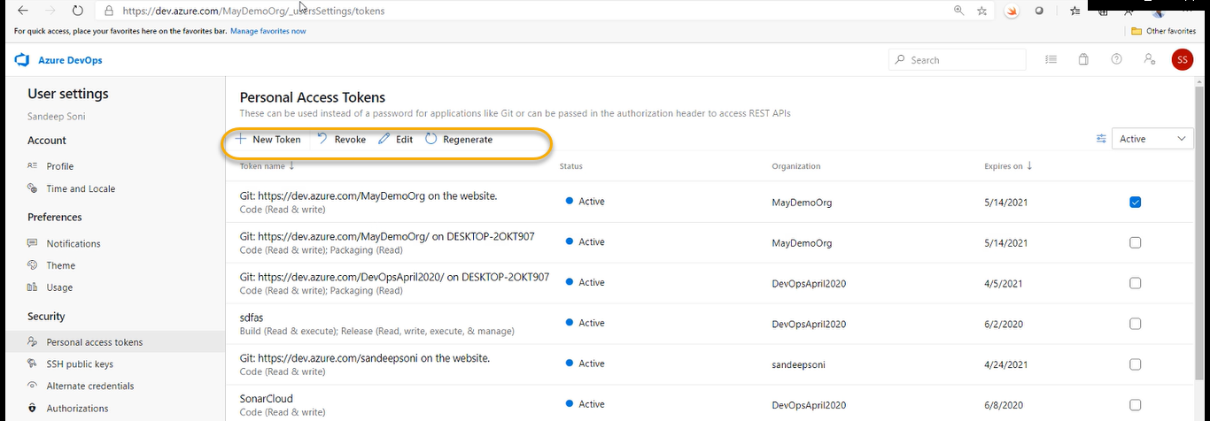

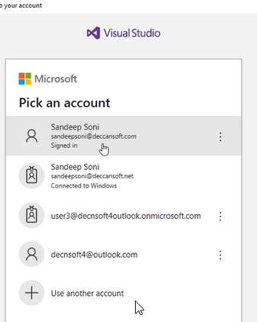

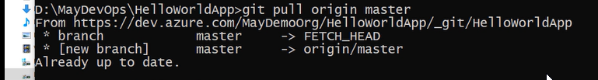

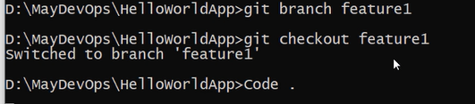

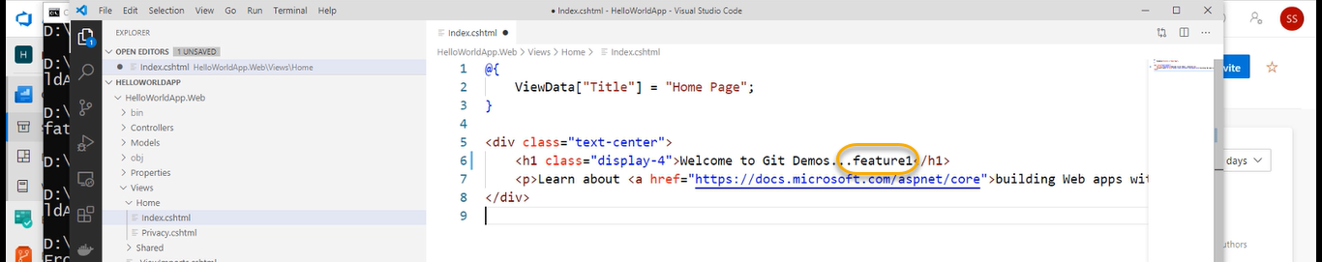



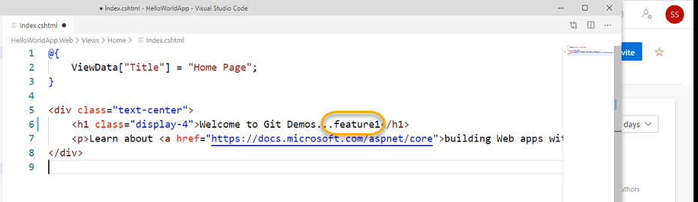

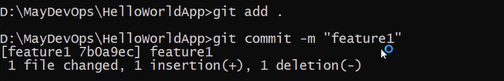



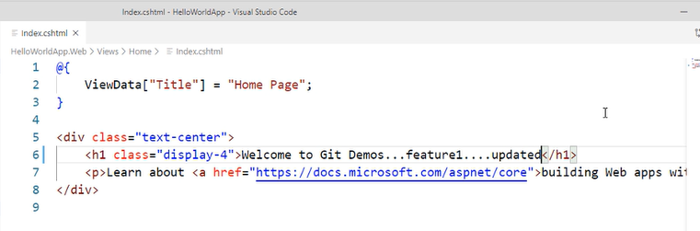

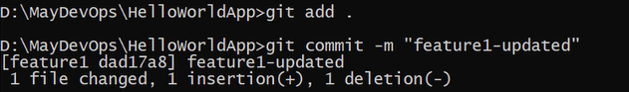

git log

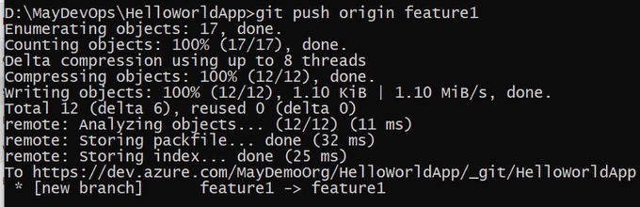

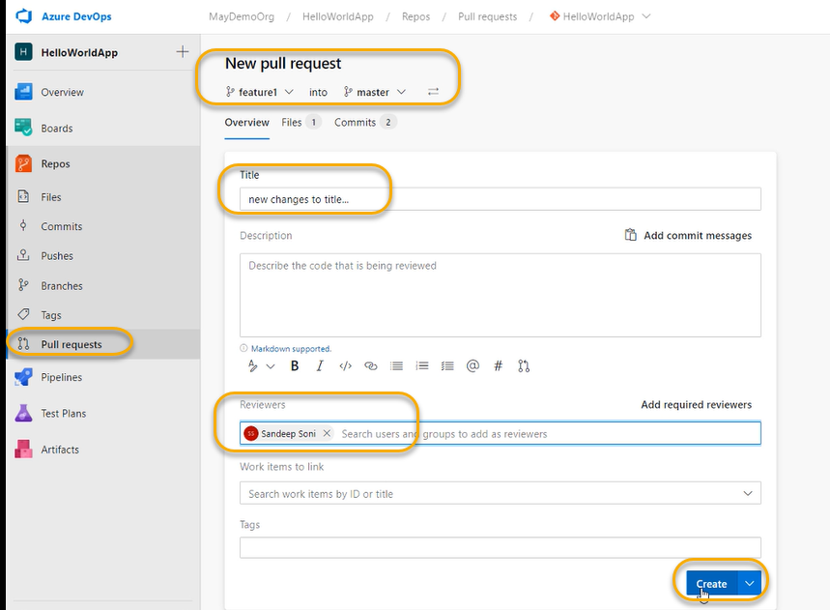

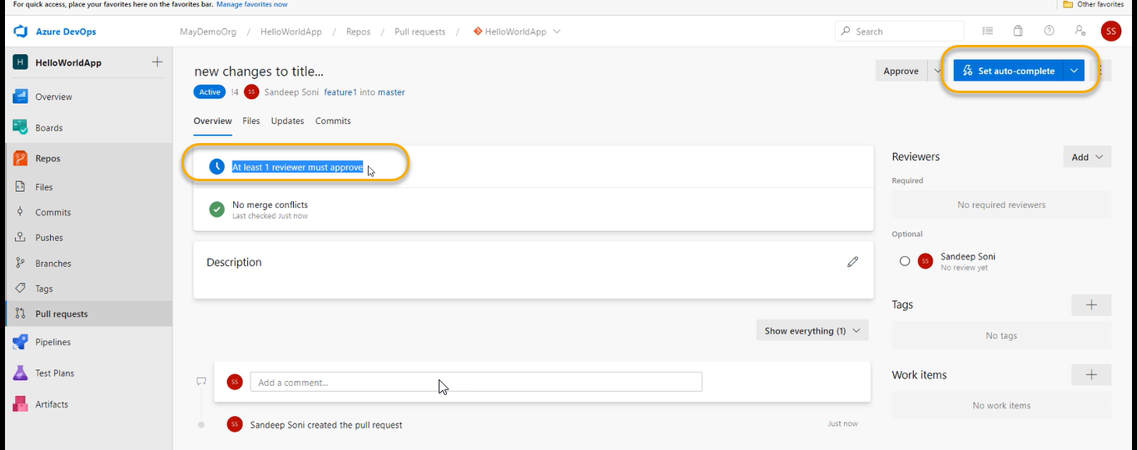

We can do this by auto complete one that means if one user approves then automatically auto process completes

A mail will go and approve it

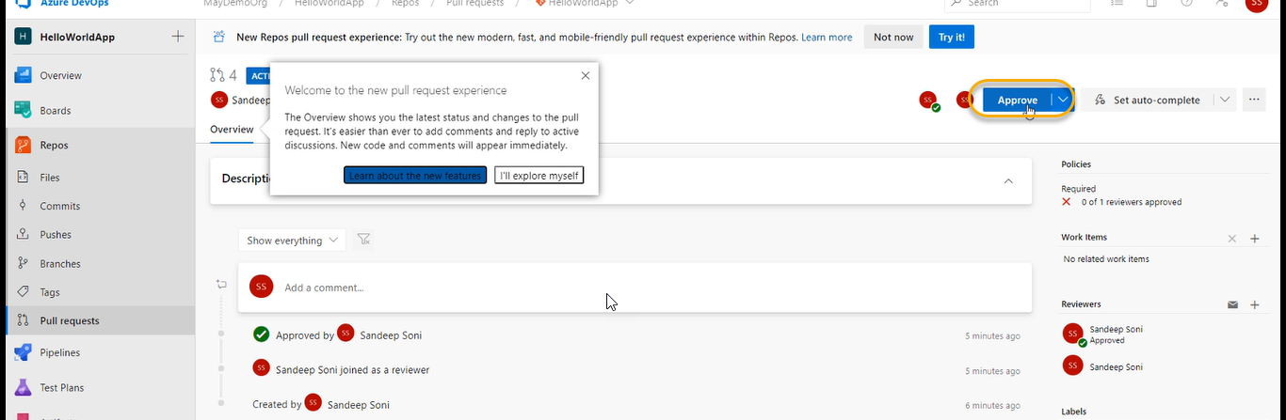

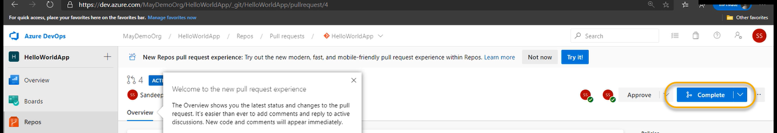

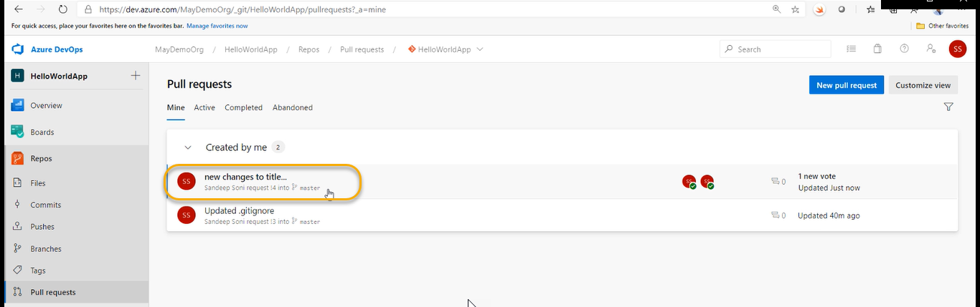

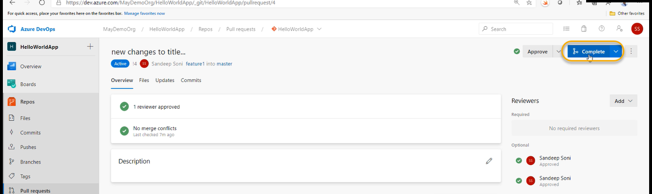

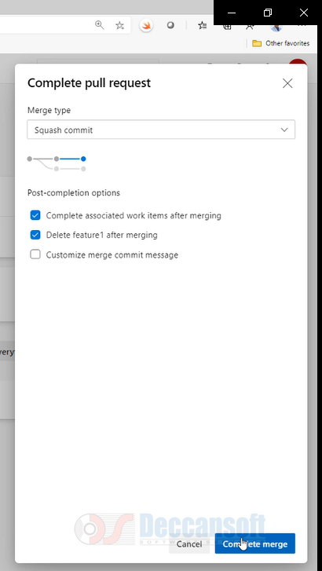

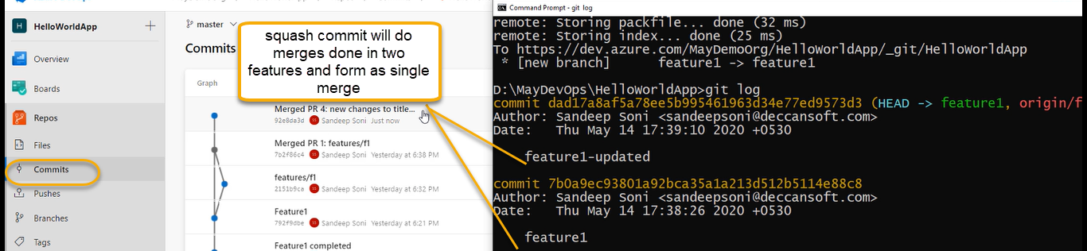

After doing the squash we need to delete the feature branch

Before delete feature branch

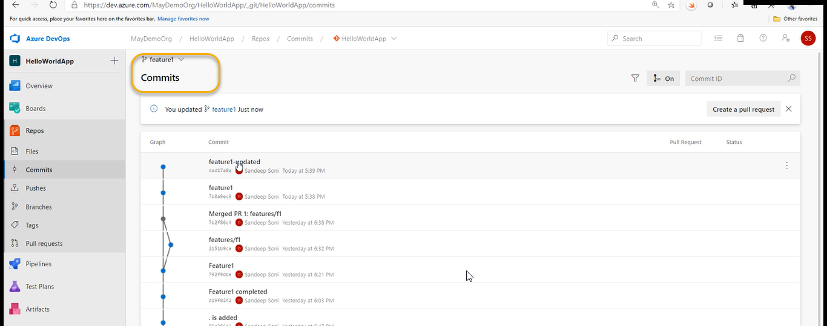

After deleting the feature branch



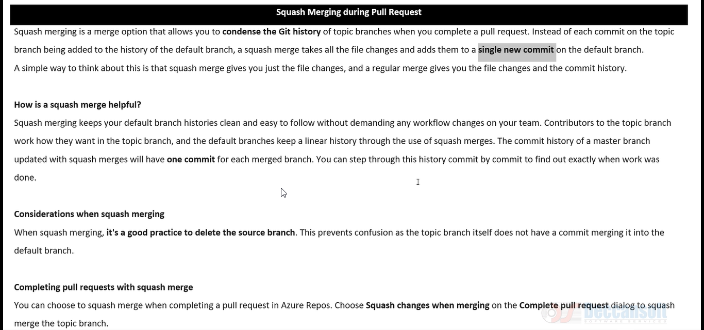

You don’t have history how commits have been done because everything got merged at one place

And if the developers says one particular point you need to rollback we cannot do this

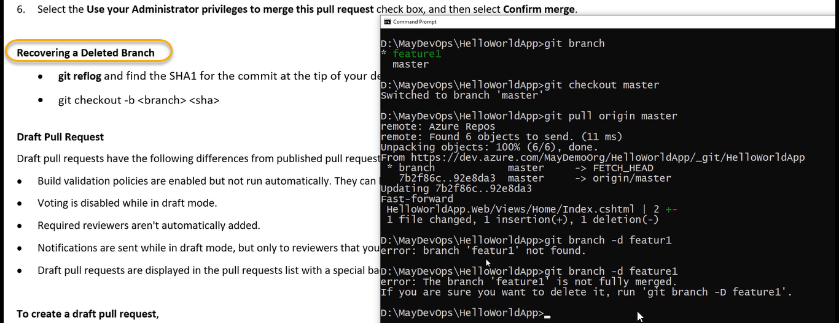

Because of squash merge issue occurs

git branch -D feature 1

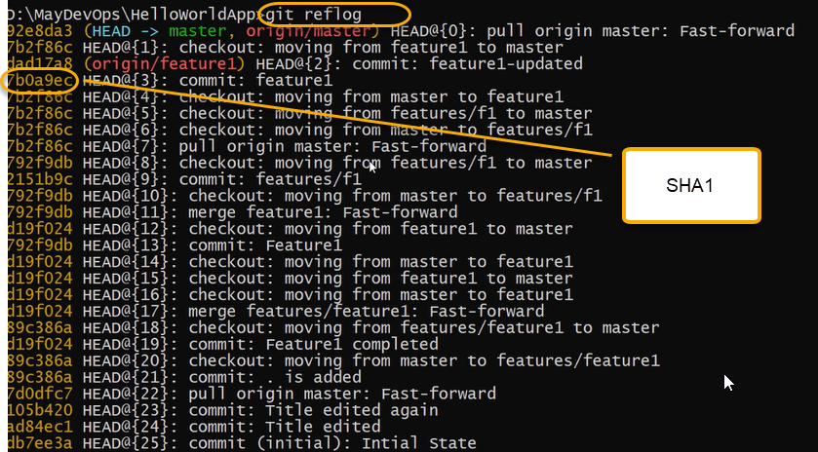



git branch

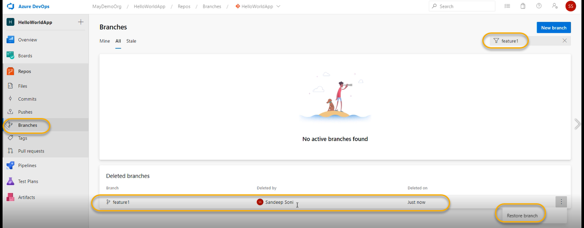

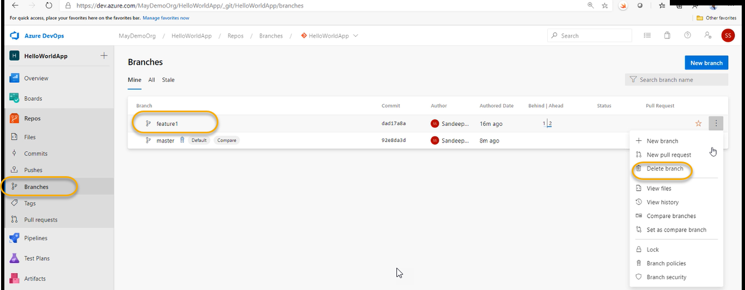

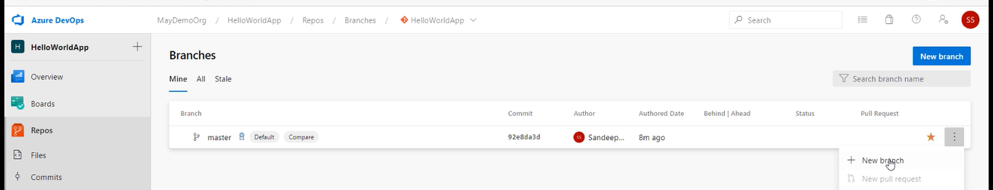

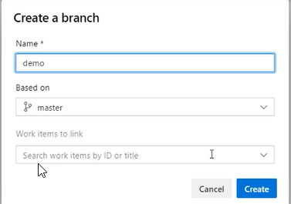

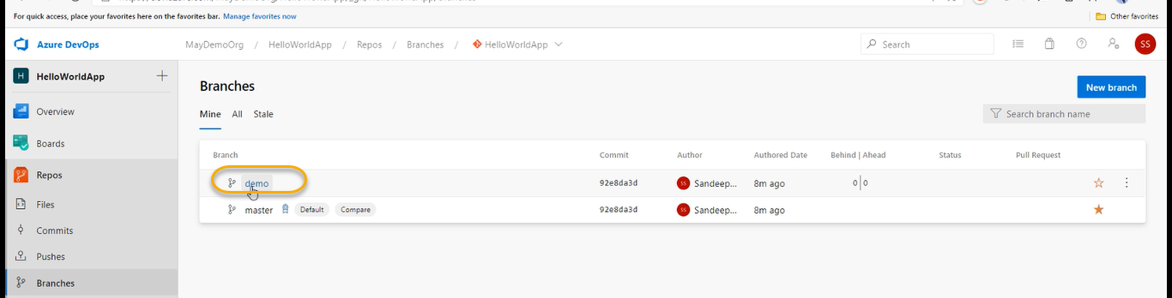

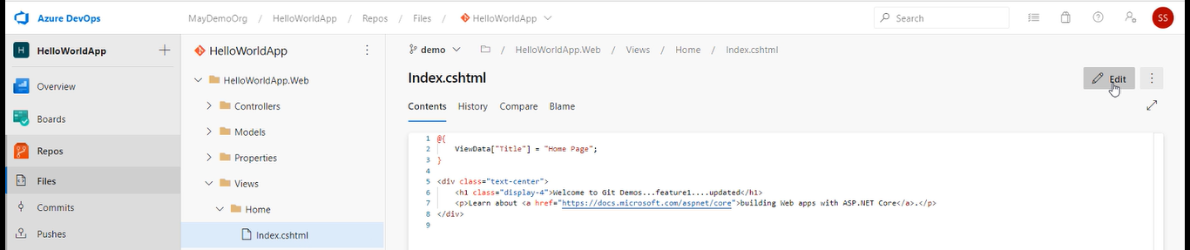

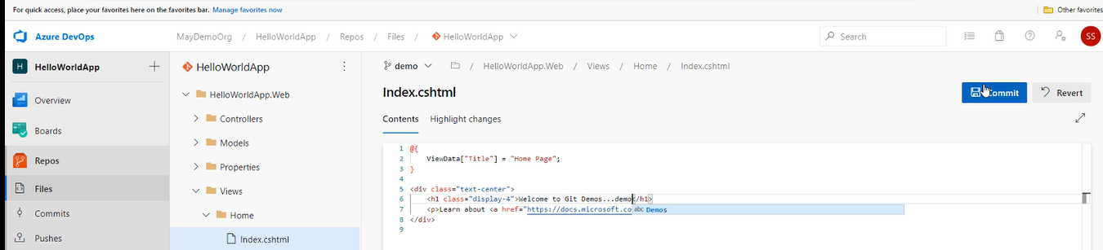

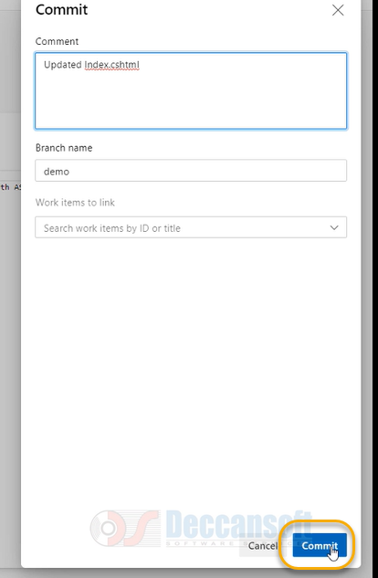

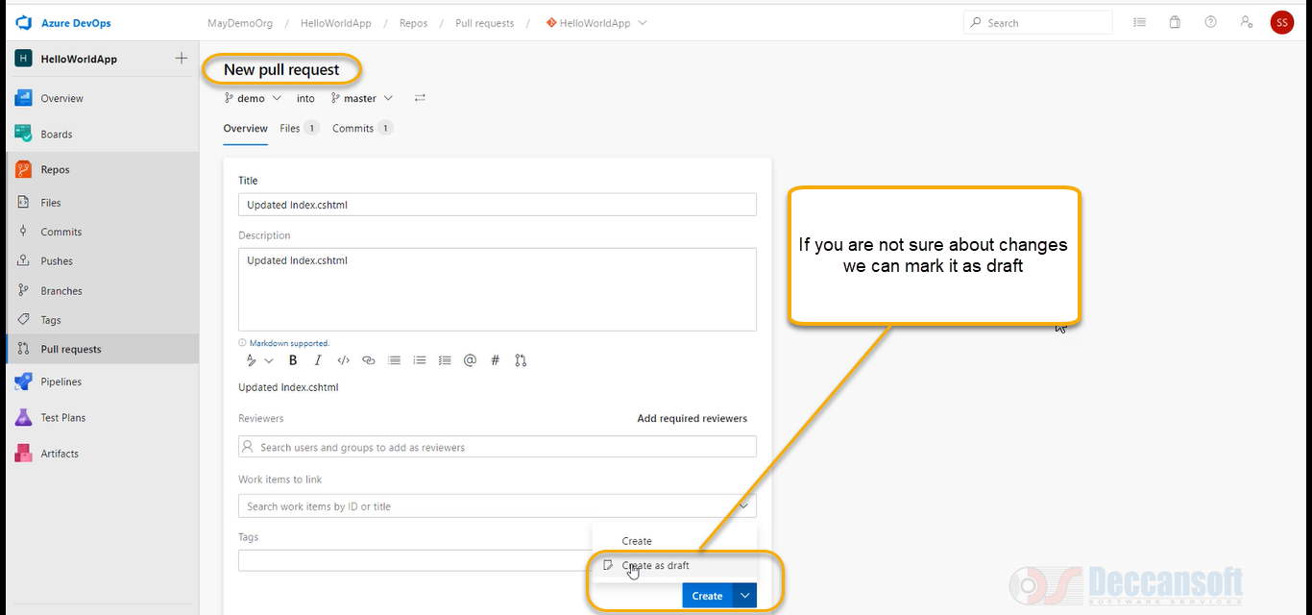

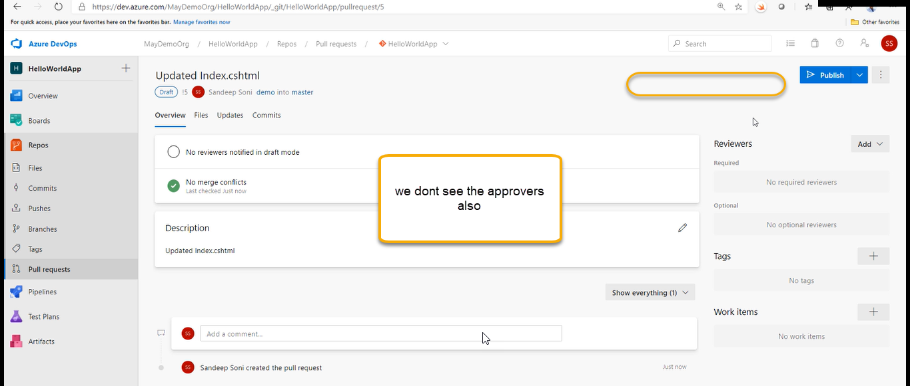

If the code is good enough then we can click on ‘’Publish”

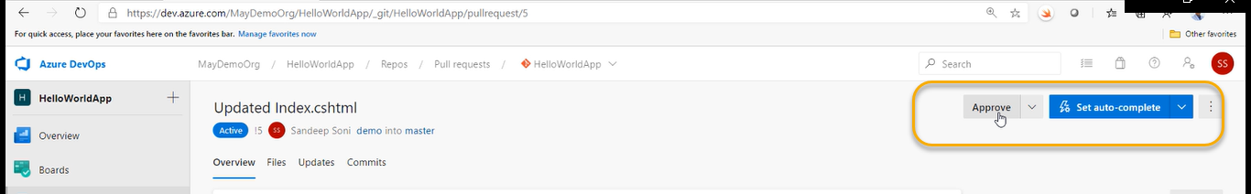

How to revert back to changes

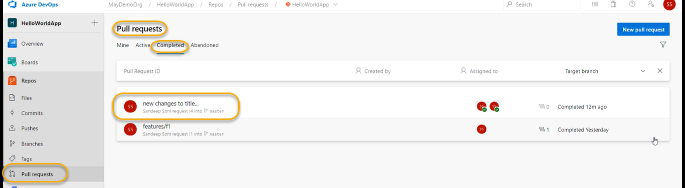

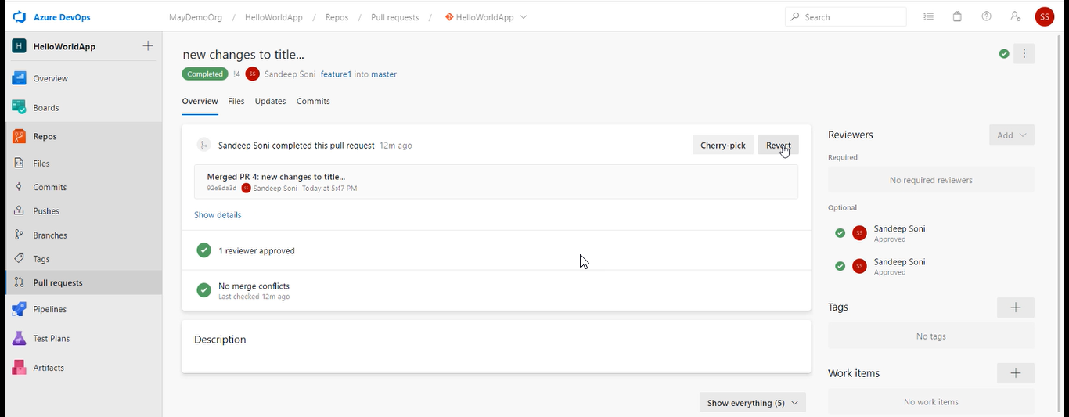

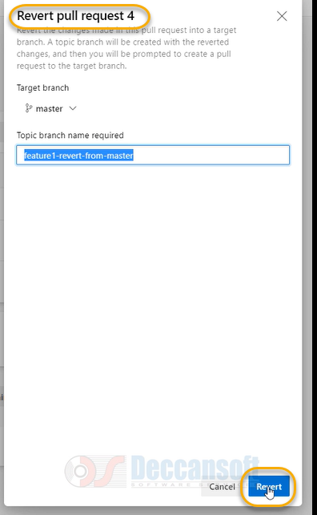

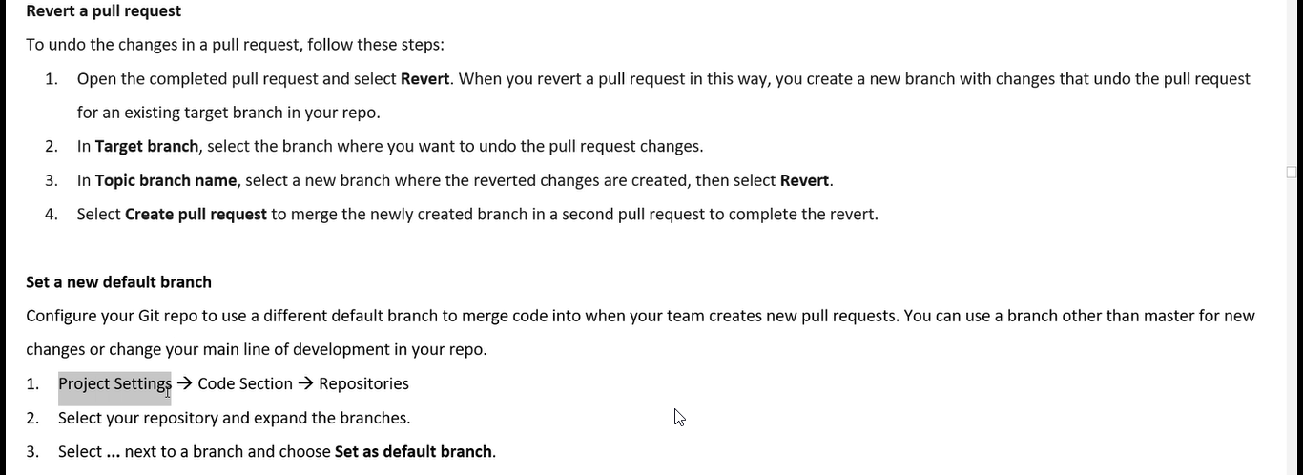

To set the default branch

